Java Numbers Class
Normally, when we work with Numbers, we use primitive data types such as byte, int, long, double etc.

Example:
int i = 5000;
float gpa = 13.65;
byte mask = 0xaf;
However in development we come across situations were we need to use objects instead of primitive data types. In-order to achieve this Java provides wrapper classes for each primitive data type.
All the wrapper classes ( Integer, Long, Byte, Double, Float, Short) are subclasses of the abstract class Number.
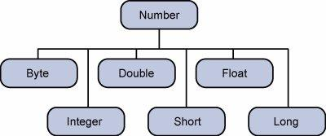
This wrapping is taken care of by the compiler process is called boxing. So when a primitive is used when an object is required the compiler boxes the primitive type in its wrapper class. Similarly the compiler unboxes the object to a primitive as well. The Number is part of the java.lang package.
Here is an example of boxing and unboxing:
public class Test{

public static void main(String args[]){
Integer x = 5; // boxes int to an Integer object
x = x + 10; // unboxes the Integer to a int
System.out.println(x);
}
}
This would produce following result:
15
When x is assigned integer values, the compiler boxes the integer because x is integer objects. Later, x is unboxed so that they can be added as integers.

Number Methods:
Here is the list of the instance methods that all the subclasses of the Number class implement:
Methods with Description
compareTo()
Compares this Number object to the argument.
equals()
Determines whether this number object is equal to the argument.
valueOf()
Returns an Integer object holding the value of the specified primitive.
toString()
Returns a String object representing the value of specified int or Integer.
parseInt()
This method is used to get the primitive data type of a certain String.
round()
Returns the closest long or int, as indicated by the method's return type, to the argument.
min()
Returns the smaller of the two arguments.
max()
Returns the larger of the two arguments.
toRadians()
Converts the argument to radians.
random()
Returns a random number.

